**VISUALIZATION USING FILTERS**

Finding the Visualization of time spent on social media(hours) by performance in online using the local filters as follows:-

**Local filters: Gender=Male**

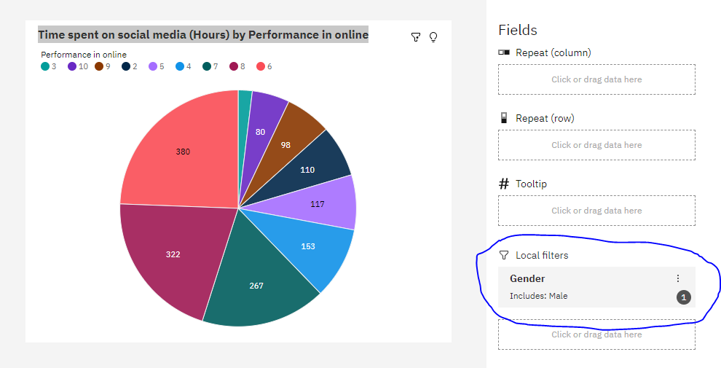

**Local filters: Gender=Female**

